Abdullah Ghayumi

634072@student.inholland.nl

Parallel Distributed Processing (HADOOP)

Assignment 3

Assignment 3

# Details

Name: Abdullah Ghayumi

Student number: 634072

GitHub URL: https://github.com/Aras53/Hadoop

Table of Contents

Details 1

Problem a 2

Solution a 3

Juyper Notebook Code 3

Result 3

Problem b 4

Solution b 4

Problem c 5

Solution c 5

Result 5

# Problem a

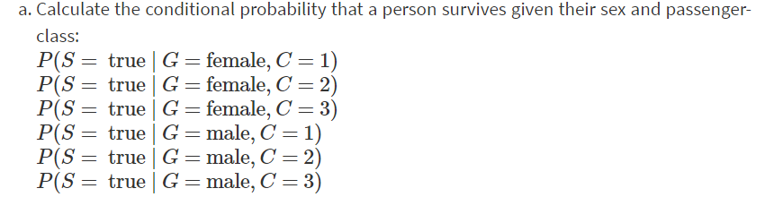

# Solution a

## Juyper Notebook Code

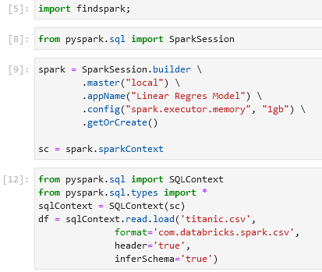

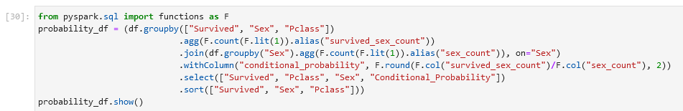

## Result

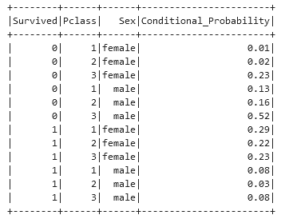

# Problem b

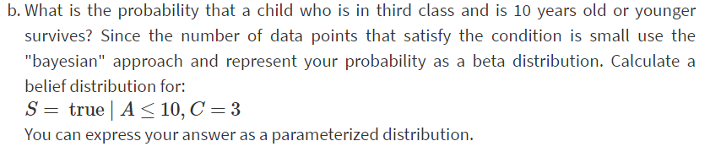

# Solution b

# Problem c

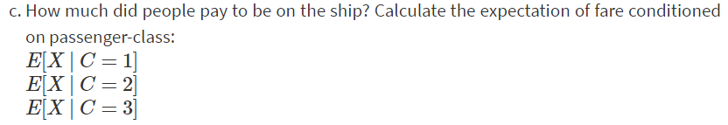

# Solution c

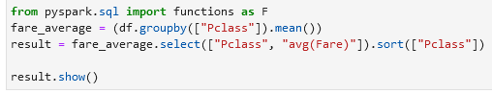

## Result

